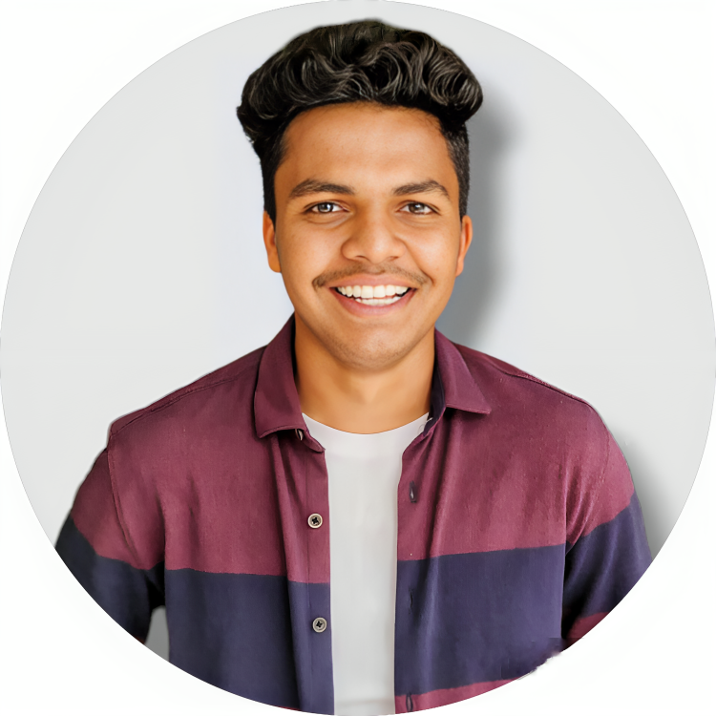

### PROFESSIONAL GOAL

* To become a successful expert in the field of Information Technology by channelizing my technical knowledge and skills to ensure personal and professional growth and to contribute to the prosperity of the organization.

### GET IN TOUCH!

**PHONE:**

* +917795450700

**EMAIL:**

* alokkumar021@outlook.in

**HOBBIES**

* Cricket
* Football
* Travelling

**PERSONAL INFORMATION:**

* Born : 21 july 2002
* Nationality : Indian

**Alok Kumar**

# **ACADEMICS**

* Bachelor of Technology (B.Tech) - 8th Semester  
  Sharnbasva University, Gulbarga , karnataka
* 7th Sem SGPA : 7.83
* 6th Sem SGPA : 6.43
* 3rd YEAR CGPA : 6.56

**PROJECTS :**

* Built sourcecode downloader website name(lastday-projects)
* Billing system on JAVA
* Voting system (frontend)
* Cloned Dream11 (frontend)

## **DECLARATION:**

## I hereby declare that all the above-mentioned information is true and correct to the best of my knowledge.

**TECHNOLOGIES KNOW:**

* HTML
* CSS
* Bootstrap
* JAVASCRIPT (CORE)
* JAVA (CORE)
* SQL (Basics)
* MONGODB (Basics)

**LANGUAGES KNOWN:**

* KANNADA
* ENGLISH
* HINDI